SAPBC_DATA_GENERATOR > programını çalıştırıyoruz.

**Temel Veri Tipleri:**

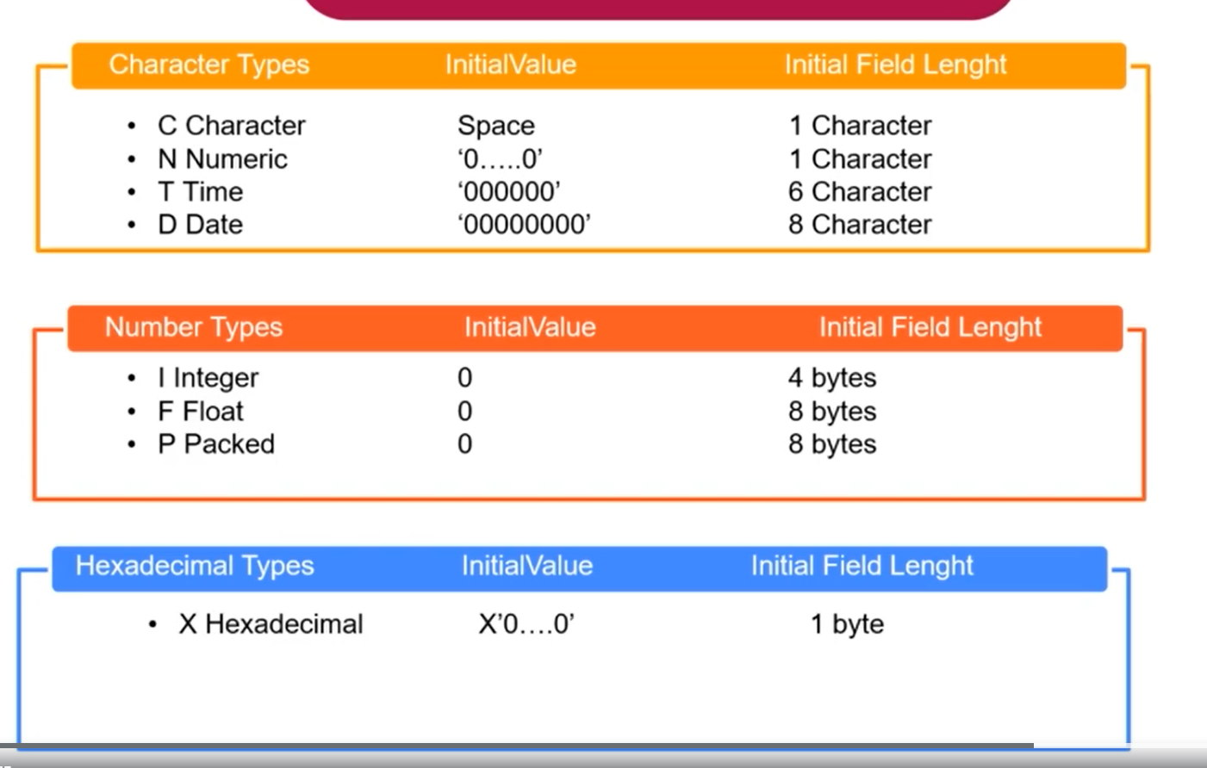

**Z_DATA_TYPES_EXAMPLE > programı oluşturalım.**

**Character:**

**TİME:**

**Data: lv_time type t.**

**Lv_time = sy-uzeit. “Current Time Server.”**

**Write: ‘Type T (Time)’**

**DATA: lv_character(60) type c value ‘Hello’**

**Write: ‘Type C Character’, lv_character.**

**Uline. (Yatay Çizgi Eklenir)**

**Numeric:**

**DATA: lv_numeric(10) type n.**

**Type D (Date)**

**Data: lv_date type d.**

**lv_tomorrow type d.**

**lv_date = sy-datum. “Current date server”**

**lv_tomorrow = lv_date + 1.**

**Write: ‘Type D (DATE)’, lv_tomorrow.**

**Uline.**

**Lv_numeric = 125458.**

**Write: ‘Numeric N ’**

**Uline.**

**INTEGER:**

**FLOAT:**

**DATA: lv_float type f.**

**Lv_float = lv_integer / 12 . “50/12”**

**Write: ‘Type F (Float)’, lv_float**

**Uline.**

**DATA: lv_integer type i value ‘50’.**

**Write: ’Type I (Integer)’, lv_integer.**

**Uline.**

**Type X (Hexadecimal)**

**DATA: lv_hexadecimal type x value ‘0A’.**

**Write: ‘Type x Hexadecimal’, lv_hexadecimal**

**Uline.**

**PACKET:**

**Data: lv_packet type p Decimals 2.**

**Lv_packet = ‘125.23.’**

**Write: ‘Type P (Packet)’**

**Uline.**